**自动获取IP地址**

1. 在交换机上配置好VLAN,将相应的端口添加到VLAN中
2. 交换机和路由器相连接的那个端口，即交换机的上联端口要配置为Trunk
3. 在路由器的接口G0/2上进入“子接口”配置

A.配置封装的vlan id

B.配置子接口IP地址

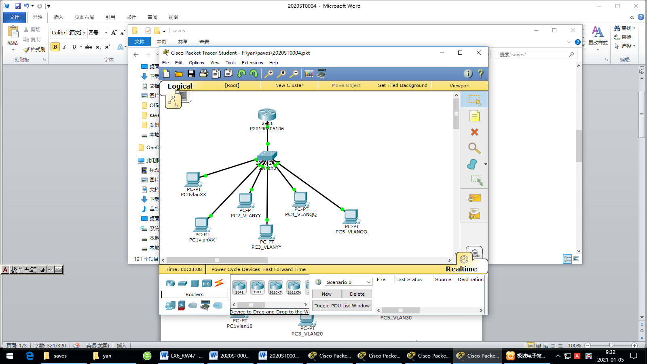

**VLAN ：**

**VLAN XXX(考生学号的后2位)**

**VLAN YYY(考生学号的后2位加30)**

**VLAN QQQ(考生学号的后2位加40)**

**例如：考生学号为：P20190305104**

**那么他用的VLAN为：**

**VLAN 4**

**VLAN 34**

**VLAN 44**

**第一层（路由器2911）**

**路由器R1（ hostname）**

**Display Name: P20190305106（考生学号）**

端口G0/0接S2960的端口24

子端口

G0/2.10 VLAN 4 IP 192.168.4.1

G0/2.20 VLAN 34 IP 192.168.34.1

G0/2.30 VLAN 44 IP 192.168. 44.1

**第二层（二层交换机）**

**左边交换机S2960-1**

端口1接计算机PC0_LANXX

端口2接计算机PC1_LANXX

端口7接计算机PC2_LANYY

端口8接计算机PC3_LANYY

端口13接计算机PC4_LANQQ

端口14接计算机PC5_LANQQ

端口1-6是属于VLANXX

端口7-12是属于VLANYY

端口13-18是属于VLANQQ

PC端的IP地址设置为DHCP自动获取

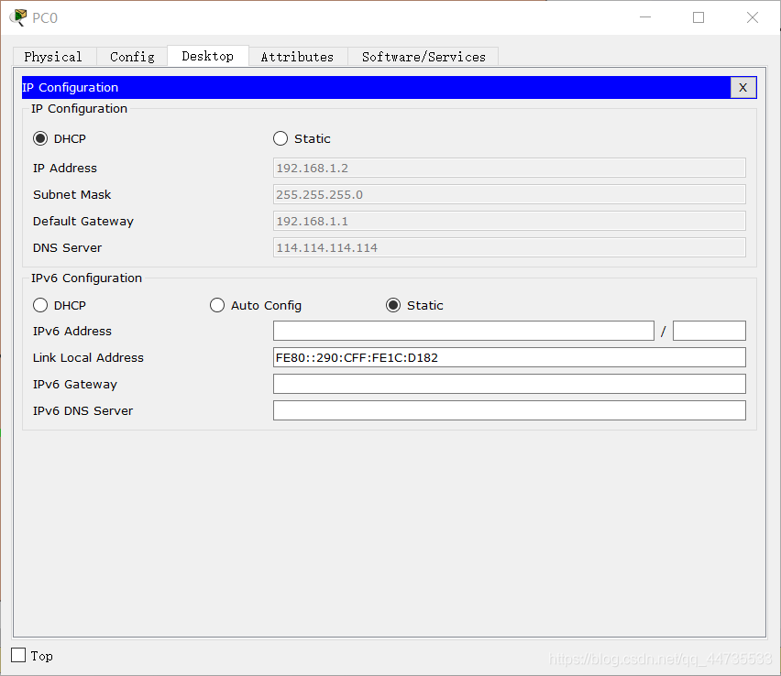

1. 配置二层交换机

C2960 Boot Loader (C2960-HBOOT-M) Version 12.2(25r)FX, RELEASE SOFTWARE (fc4)

Cisco WS-C2960-24TT (RC32300) processor (revision C0) with 21039K bytes of memory.

2960-24TT starting...

Base ethernet MAC Address: 00E0.F90B.302A

Xmodem file system is available.

Initializing Flash...

flashfs[0]: 1 files, 0 directories

flashfs[0]: 0 orphaned files, 0 orphaned directories

flashfs[0]: Total bytes: 64016384

flashfs[0]: Bytes used: 4414921

flashfs[0]: Bytes available: 59601463

flashfs[0]: flashfs fsck took 1 seconds.

...done Initializing Flash.

Boot Sector Filesystem (bs:) installed, fsid: 3

Parameter Block Filesystem (pb:) installed, fsid: 4

Loading "flash:/c2960-lanbase-mz.122-25.FX.bin"...

########################################################################## [OK]

Restricted Rights Legend

Use, duplication, or disclosure by the Government is

subject to restrictions as set forth in subparagraph

(c) of the Commercial Computer Software - Restricted

Rights clause at FAR sec. 52.227-19 and subparagraph

(c) (1) (ii) of the Rights in Technical Data and Computer

Software clause at DFARS sec. 252.227-7013.

cisco Systems, Inc.

170 West Tasman Drive

San Jose, California 95134-1706

Cisco IOS Software, C2960 Software (C2960-LANBASE-M), Version 12.2(25)FX, RELEASE SOFTWARE (fc1)

Copyright (c) 1986-2005 by Cisco Systems, Inc.

Compiled Wed 12-Oct-05 22:05 by pt_team

Image text-base: 0x80008098, data-base: 0x814129C4

Cisco WS-C2960-24TT (RC32300) processor (revision C0) with 21039K bytes of memory.

24 FastEthernet/IEEE 802.3 interface(s)

2 Gigabit Ethernet/IEEE 802.3 interface(s)

63488K bytes of flash-simulated non-volatile configuration memory.

Base ethernet MAC Address : 00E0.F90B.302A

Motherboard assembly number : 73-9832-06

Power supply part number : 341-0097-02

Motherboard serial number : FOC103248MJ

Power supply serial number : DCA102133JA

Model revision number : B0

Motherboard revision number : C0

Model number : WS-C2960-24TT

System serial number : FOC1033Z1EY

Top Assembly Part Number : 800-26671-02

Top Assembly Revision Number : B0

Version ID : V02

CLEI Code Number : COM3K00BRA

Hardware Board Revision Number : 0x01

Switch Ports Model SW Version SW Image

------ ----- ----- ---------- ----------

* 1 26 WS-C2960-24TT 12.2 C2960-LANBASE-M

Cisco IOS Software, C2960 Software (C2960-LANBASE-M), Version 12.2(25)FX, RELEASE SOFTWARE (fc1)

Copyright (c) 1986-2005 by Cisco Systems, Inc.

Compiled Wed 12-Oct-05 22:05 by pt_team

Press RETURN to get started!

%LINK-5-CHANGED: Interface FastEthernet0/1, changed state to up

%LINEPROTO-5-UPDOWN: Line protocol on Interface FastEthernet0/1, changed state to up

%LINK-5-CHANGED: Interface FastEthernet0/2, changed state to up

%LINEPROTO-5-UPDOWN: Line protocol on Interface FastEthernet0/2, changed state to up

%LINK-5-CHANGED: Interface FastEthernet0/7, changed state to up

%LINEPROTO-5-UPDOWN: Line protocol on Interface FastEthernet0/7, changed state to up

%LINK-5-CHANGED: Interface FastEthernet0/8, changed state to up

%LINEPROTO-5-UPDOWN: Line protocol on Interface FastEthernet0/8, changed state to up

%LINK-5-CHANGED: Interface FastEthernet0/13, changed state to up

%LINEPROTO-5-UPDOWN: Line protocol on Interface FastEthernet0/13, changed state to up

%LINK-5-CHANGED: Interface FastEthernet0/14, changed state to up

%LINEPROTO-5-UPDOWN: Line protocol on Interface FastEthernet0/14, changed state to up

Switch>en

Switch#conf t

Enter configuration commands, one per line. End with CNTL/Z.

Switch(config)#vlan 4

Switch(config-vlan)#exit

Switch(config)#vlan 34

Switch(config-vlan)#exit

Switch(config)#vlan 44

Switch(config-vlan)#exit

Switch(config)#int range Fa0/1-6

Switch(config-if-range)#switchport access vlan 4

Switch(config-if-range)#

Switch(config-if-range)#exit

Switch(config)#int range Fa0/7-12

Switch(config-if-range)#switchport access vlan 34

Switch(config-if-range)#exit

Switch(config)#int range Fa0/13-24

Switch(config-if-range)#switchport access vlan 44

Switch(config-if-range)#exit

Switch(config)#int f0/9

Switch(config-if)#switchport mode trunk

Switch(config-if)#switchport trunk allowed vlan all

Switch(config-if)#enf

^

% Invalid input detected at '^' marker.

Switch(config-if)#end

Switch#

%SYS-5-CONFIG_I: Configured from console by console

Switch con0 is now available

Press RETURN to get started.

%LINK-5-CHANGED: Interface FastEthernet0/24, changed state to up

%LINEPROTO-5-UPDOWN: Line protocol on Interface FastEthernet0/24, changed state to up

1. 配置路由器
2. Router con0 is now available
3. Press RETURN to get started.
4. Router>enable
5. Router#coinfigure trminal
6. ^
7. % Invalid input detected at '^' marker.
8. Router#int g0/0
9. ^
10. % Invalid input detected at '^' marker.
11. Router#int g0/0
12. ^
13. % Invalid input detected at '^' marker.
14. Router#configure terminal
15. Enter configuration commands, one per line. End with CNTL/Z.
16. Router(config)#int g0/0
17. Router(config-if)#no shutdown
18. Router(config-if)#
19. %LINK-5-CHANGED: Interface GigabitEthernet0/0, changed state to up
20. %LINEPROTO-5-UPDOWN: Line protocol on Interface GigabitEthernet0/0, changed state to up
21. Router(config-if)#exit
22. Router(config)#interface GigabitEthernet0/0
23. Router(config-if)#int g0/0.1
24. Router(config-subif)#
25. %LINK-5-CHANGED: Interface GigabitEthernet0/0.1, changed state to up
26. %LINEPROTO-5-UPDOWN: Line protocol on Interface GigabitEthernet0/0.1, changed state to up
27. Router(config-subif)#encapsulation dot1q 10
28. Router(config-subif)#ip address 192.168.1.1.255.255.255.0
29. ^
30. % Invalid input detected at '^' marker.
31. Router(config-subif)#ip address192.168.1.1.255.255.255.0
32. ^
33. % Invalid input detected at '^' marker.
34. Router(config-subif)#ip address 192.168.1.1255.255.255.0
35. ^
36. % Invalid input detected at '^' marker.
37. Router(config-subif)#
38. Router con0 is now available
39. Press RETURN to get started.
40. Router>en
41. Router#conf t
42. Enter configuration commands, one per line. End with CNTL/Z.
43. Router(config)#int g0/2
44. Router(config-if)#no shutdown
45. Router(config-if)#
46. %LINK-5-CHANGED: Interface GigabitEthernet0/2, changed state to up
47. Router(config-if)#exit
48. Router(config)#interface GigabitEthrenet0/2
49. ^
50. % Invalid input detected at '^' marker.
51. Router(config)#interface GigabitEthernet0/2
52. Router(config-if)#int g0/0.2
53. Router(config-subif)#
54. %LINK-5-CHANGED: Interface GigabitEthernet0/0.2, changed state to up
55. %LINEPROTO-5-UPDOWN: Line protocol on Interface GigabitEthernet0/0.2, changed state to up
56. Router(config-subif)#encapsulation dot1q
57. % Incomplete command.
58. Router(config-subif)#encapsulation dot1q 08
59. Router(config-subif)#ip address 192.168.04.1.255.255.255.0
60. ^
61. % Invalid input detected at '^' marker.
62. Router(config-subif)#ip address 192.168.04.1 255.255.255.0
63. Router(config-subif)#no shutdown
64. Router(config-subif)#exit
65. Router(config)#ip dhcp pool hr
66. Router(dhcp-config)#default-router 192.168.04.1
67. Router(dhcp-config)#network 192.168.04 255.255.255.0
68. ^
69. % Invalid input detected at '^' marker.
70. Router(dhcp-config)#network 192.168.04.0 255.255.255.0
71. Router(dhcp-config)#dns-server 114.114.114.14
72. Router(dhcp-config)#exit
73. Router(config)#g0/2.2
74. ^
75. % Invalid input detected at '^' marker.
76. Router(config)#g0/2.2
77. ^
78. % Invalid input detected at '^' marker.
79. Router(config)#int g0/2.2
80. Router(config-subif)#
81. %LINK-5-CHANGED: Interface GigabitEthernet0/2.2, changed state to up
82. Router(config-subif)#no shutdown
83. Router(config-subif)#encapsulation dot1q 34
84. Router(config-subif)#ip address 192.168.34.1 255.255.255.0
85. Router(config-subif)#exit
86. Router(config)#ip dhcp pool lT
87. Router(dhcp-config)#default-router 192.168.34.1
88. Router(dhcp-config)#network 192.168.38.0 255.255.255.0
89. Router(dhcp-config)#dns-server 114.114.114.144
90. Router(dhcp-config)#exit
91. Router(config)#int g0/2.3
92. Router(config-subif)#
93. %LINK-5-CHANGED: Interface GigabitEthernet0/2.3, changed state to up
94. Router(config-subif)#encapsulation dot1q 44
95. Router(config-subif)#%DHCPD-4-G??
96. ^
97. % Invalid input detected at '^' marker.
98. Router(config-subif)#?
99. Router(config-subif)#
100. Router(config-subif)#
101. Router(config-subif)#
102. Router(config-subif)#
103. Router(config-subif)#
104. Router(config-subif)#
105. Router(config-subif)#
106. Router(config-subif)#
107. Router(config-subif)#
108. Router(config-subif)#
109. Router(config-subif)#
110. Router(config-subif)#
111. Router(config-subif)#
112. Router(config-subif)#
113. Router(config-subif)#DHCPD%
114. ^
115. % Invalid input detected at '^' marker.
116. Router(config-subif)#ip address 192.168.44.1
117. % Incomplete command.
118. Router(config-subif)#no shutdown
119. Router(config-subif)#exit
120. Router(config)#ip dhcp pool SA
121. Router(dhcp-config)#default-router 192.168.44.1
122. Router(dhcp-config)#192.168.44.0 255.255.255.0
123. ^
124. % Invalid input detected at '^' marker.
125. Router(dhcp-config)#network 192.168.44.0 255.255.255.0
126. Router(dhcp-config)#